0,37 kW 1500 rpm PMSM Motor 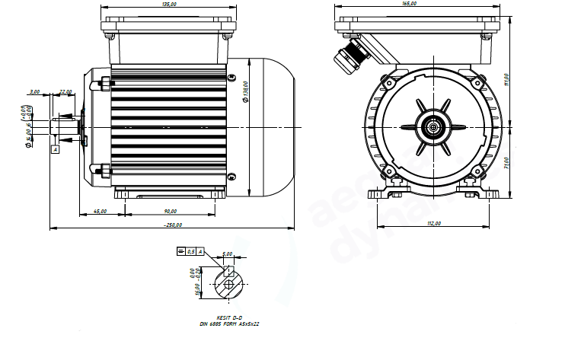
Basic Motor Parameters
Rated Power | W | 370
Rated Speed | rpm | 1500
Rated Torque | Nm | 2.4
Rated Current | A | 3.5
Rated Voltage | V | 220
No-Load Speed | rpm | 1700
Max. Efficiency | % | 80
Electrical Parameters
Number of Phases |  | 3
Number of Poles |  | 10
Torque Constant (KT) | Nm/A | 1.97
Back EMF Constant (KE) | Vs/rad | 1.61
Terminal Resistance Phase to Phase (±%10) | mΩ | 6.5
Terminal Inductance Phase to Phase (±%30) | mH | 14
Thermal Data
Ambient Temperature | °C | -40...+85
Max. Winding Temperature | °C | +155
Physical Parameters
Outer Diameter | mm | 138
Shaft Diameter | mm | 14
Max. Lenght | mm | 250
Weight | gr | ~3500
Motor Connection
U, V, W | M20 Cable Gland
Sensor Connection
N/A | N/A
Connector Articles
Power | N/A
Signal | N/A
20V 370W 1500 rpm GMM PM Motor B5 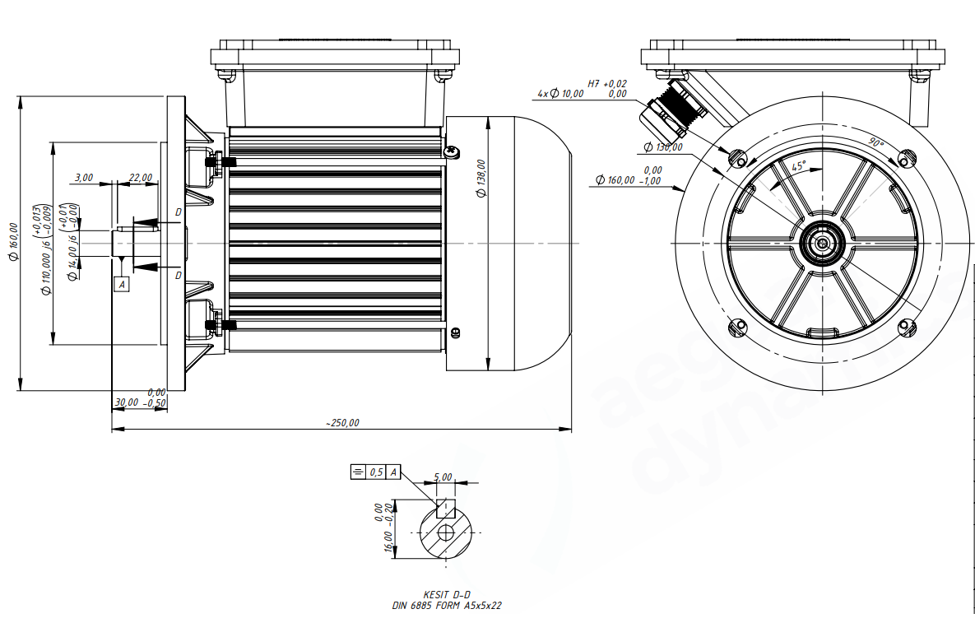
Basic Motor Parameters
Rated Power | W | 370
Rated Speed | rpm | 1500
Rated Torque | Nm | 2.4
Rated Current | A | 3.5
Rated Voltage | V | 220
No-Load Speed | rpm | 1700
Max. Efficiency | % | 80
Electrical Parameters
Number of Phases |  | 3
Number of Poles |  | 10
Torque Constant (KT) | Nm/A | 1.97
Back EMF Constant (KE) | Vs/rad | 1.61
Terminal Resistance Phase to Phase (±%10) | mΩ | 6.5
Terminal Inductance Phase to Phase (±%30) | mH | 14
Thermal Data
Ambient Temperature | °C | -40...+85
Max. Winding Temperature | °C | +155
Physical Parameters
Outer Diameter | mm | 138
Shaft Diameter | mm | 14
Max. Lenght | mm | 250
Weight | gr | ~3500
Motor Connection
U, V, W | M20 Cable Gland
Sensor Connection
N/A | N/A
Connector Articles
Power | N/A
Signal | N/A
20V 370W 1500 rpm GMM PM Motor B35 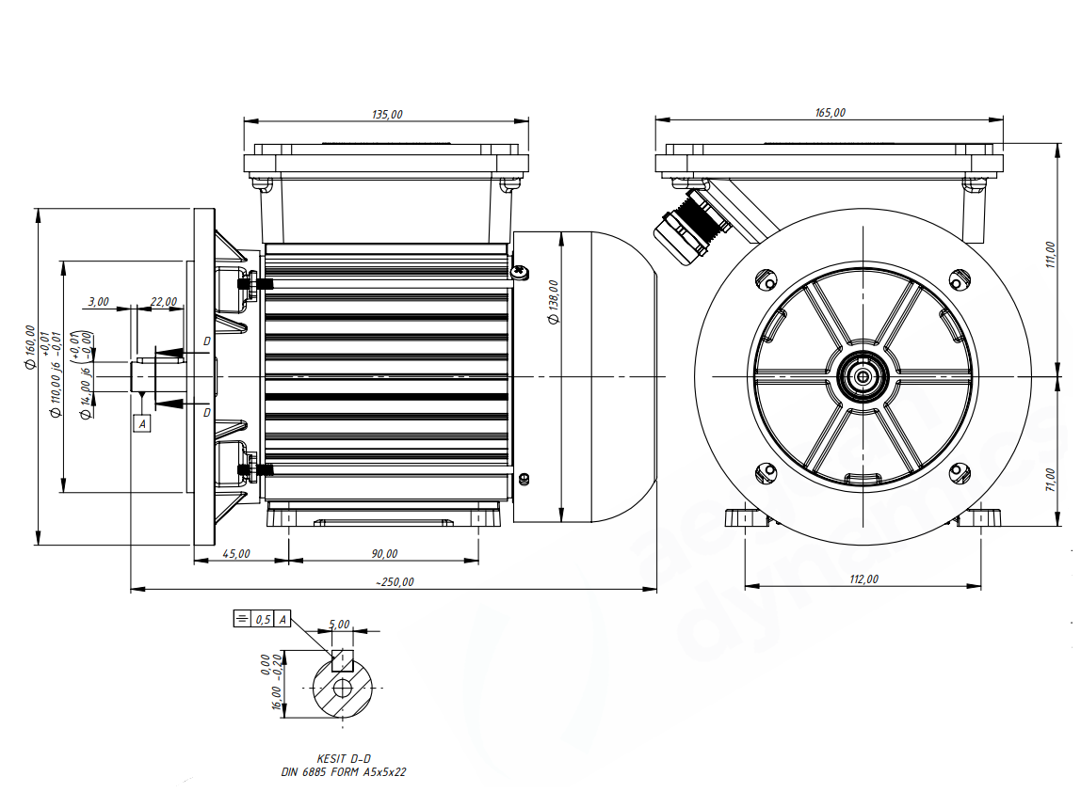
Basic Motor Parameters
Rated Power | W | 370
Rated Speed | rpm | 1500
Rated Torque | Nm | 2.4
Rated Current | A | 3.5
Rated Voltage | V | 220
No-Load Speed | rpm | 1700
Max. Efficiency | % | 80
Electrical Parameters
Number of Phases |  | 3
Number of Poles |  | 10
Torque Constant (KT) | Nm/A | 1.97
Back EMF Constant (KE) | Vs/rad | 1.61
Terminal Resistance Phase to Phase (±%10) | mΩ | 6.5
Terminal Inductance Phase to Phase (±%30) | mH | 14
Thermal Data
Ambient Temperature | °C | -40...+85
Max. Winding Temperature | °C | +155
Physical Parameters
Outer Diameter | mm | 138
Shaft Diameter | mm | 14
Max. Lenght | mm | 250
Weight | gr | ~3500
Motor Connection
U, V, W | M20 Cable Gland
Sensor Connection
N/A | N/A
Connector Articles
Power | N/A
Signal | N/A

